Year 1 Non-Negotiables Checklist for Independent Writing
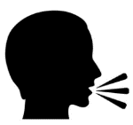 | Orally rehearse sentence before writing.
 | Punctuate sentences using a correctly formed capital letter at the start.
 | Know how to use a capital letter for names, places, and the personal pronoun I.
 | Punctuate sentences with a full stop.
 | Be aware of how and when to use ?.!
 | Leave finger spaces between words.
  ascenders  decenders | Form small letters that sit correctly the line correctly.  abcdehiklmnorstuvwxz  fgjpqy
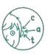 | Segment words into phonemes and represent these graphemes spelling some words correctly.
have like  little one | Spell Year 1 words correctly in their writing.
 | Re-read work to check it makes sense.
un | Understand how the prefix un changes the meaning if verbs and adjectives.
ing, er, est | Add suffixes to verbs where no change is needed.
s, es | Use plural suffixes
and | Join words and clauses using and

