LONG TERM PLAN
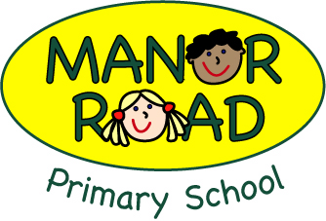

English 2026 2027

Year | Autumn 1 | Autumn 2 |  | Spring 1 |  | Spring 2 |  |  | Summer 1 |  | Summer 2
Pre-School Texts  CYCLE A | Nursery Rhymes and various rhymes from Poetry Basket  Marvellous Me  Owl Babies  Brown Bear, Brown Bear What Do You See?  Stanley’s Stick  Topsy & Tim Start School  I Need A Wee | We’re Going On A Bear Hunt  What’s in the Witches Kitchen?  Meg and Mog  The Happy Pumpkin  The Quietest Firework  Dear Santa  The First Christmas  Shark in the Snow  We’re Going On A Pumpkin Hunt |  | Polar Bear Polar Bear, What do you hear?  Mr Wolf’s Pancakes  Non Fiction books – Winter  Hot & Cold  Cleversticks (CNY)  Ten Little Penguins  Snowball  That’s not my snowman  That’s not my penguin  One Warm Fox  William’s Winter Nap  Bear Snores On |  | Non fiction books – Police officer, Firefighters, Paramedics, The Dentist, Doctors  Peppa Pig at the Doctors  Peppa Pig Dentist Trip  Peppa Pig and the Tooth Fairy  Topsy & Tim Meet the Firefighters  What am I made of?  Guess How Much I Love You (Mother’s Day) |  |  | Titch  The Very Hungry Caterpillar  The Bad Tempered Ladybird  Mad About Minibeasts  The Very Lazy Ladbird  Norman the Slug with the Silly Shell |  | Zog  Mrs Pirate  We’re Going On A Treasure Hunt  The Bog Baby  Bumpus Jumpus Dinosaur Rumpus  Whatever Next!  Dear Zoo  Walking Through the Jungle  Aliens Love Underpants  Nobot the Robot  Supertato  Aliens Love Underpants  Zog & the Flying Doctor  Ten Little Pirates  Pirate Pete  Pirates Love Underpants
Pre-School Texts  CYCLE B | Nursery Rhymes and various rhymes from Poetry Basket  Super Duper You  The Colour Monster  I Have To Start At School Today  What do I look like?  Who’s in the loo? | The Best Diwali Ever  The Quiet Little Firework  Funny bones  Christopher Pumpkin  Room on the Broom  The First Christmas  Kipper’s Christmas Eve |  | Barry the Fish With Fingers  Shark in the Park  Shark in the Dark  Commotion in the Ocean  Oi Frog!  The Snail and the Whale |  | Mr Gumpy’s Outing  Duck in a Truck  Oi! Get Off Our Train  Will’s Wheels Shop  Down at the Station  Car Car Truck Jeep  Wheels on the Bus  The Hundred Decker Bus |  |  | Oliver’s Vegetables  Oliver’s Fruit Salad  Oliver’s Milkshake  Jack and the Beanstalk  Jasper’s Beanstalk  Oh Dear!  Where’s My Egg? |  | The Three Little Pigs  Goldilocks and the Three Bears  The Little Red Hen  The Three Billy Goats Gruff
Pre- School | On entry assessments  Mark making  Colouring  Beginning to make random marks on paper and say what it is | Knows that print carries meaning and in English, is read from left to right and top to bottom |  | Makes representational drawings including features which can be recognised by others |  | Begins to imitate writing by making continuous lines of shapes and symbols from left to right |  |  | Can copy and write some or all letters from name  Begins to write single letter sounds (SATPIN) |  | Begins to write single letter sounds for all sounds taught  Can write some simple cvc words using sounds taught  Introduce children to phase 2 tricky words in writing as well as reading
Pre-School Fine Motor | I can create lines and circles pivoting from the shoulder and elbow using large chalk | I can manipulate a range of tools and equipment in one hand, including paintbrushes, toothbrushes, scarves or ribbons |  |   I am able to demonstrate increasing control during fine motor activities such as a pincer grasp to pick up objects |  | I can use loop scissors to make snips in paper or follow a simple line |  |  | 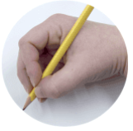  I can use a pronate grasp or a quadupod grasp with good control when holding pencils to draw lines and create |  | I am beginning to learn how to use a knife and fork
Year | Autumn 1 | Autumn 2 |  | Spring 1 |  | Spring 2 |  |  | Summer 1 |  | Summer 2
Reception Texts | Stick Man  The Smartest Giant  Giraffes’s can’t dance  Ruby’s Worry  Narrative Story  Funny Bones -various  The Big Book of Families  Pete the Cat  Room on the Broom | The Jolly Postman  Goldilocks  Range of Fairytales  Farmer Duck  Hansel & Gretal  The Ugly Duckling  Christmas Story / Nativityi  The Rainbow Fish  Narrative Story |  | The Emperors Egg  We’re going on a Bear Hunt  Narrative Adventure  The Very Hungry Caterpillar  Aghh Spider!  Tiger who came to tea  Handa’s Surprise  Narrative Story  Poetry in Book Week |  | The Tiny Seed  Oliver’s Vegetables  Jack and the Beanstalk  One Plastic Bag  DTree, Seasons come and seasons go  A stroll through the seasons  Bog Baby  How to make a chocolate mud cake  Non-Fiction Instructions |  |  | The Snail and the Whale  The Naughty Bus  Mr. Gumpy’s Outing  The Train Ride  Bob, The Man on the Moon  Oi! Get off my train!  I Wanna Iguana |  | Dinosaur Dinners non fiction  Harry and his bucketful of dinosaurs  The dinosaur that pooped a planet  If Sharks Disappeared  Non-Fiction Report
Reception | Assessments/ on entry – starting Phase 2 phonics  Writing single letters  Writing some simple satpin cvc words | Name writing  Labelling  Initial sounds  Retelling stories in the writing area  Sequencing  Write a simple sentence with Phase 2 sounds |  | Writing tricky words I go no to into the  Writing cvc words in sentences  Writing some cvcc and ccvc words  Guided writing sentences |  | Creating own story maps  Writing captions and labels with some Phase 3 sounds  Writing simple sentences  Writing instructions  Write 2 sentences  Attempt full stops and capital letters in writing |  |  | Writing lists  Writing for a purpose in provision using sounds learnt so far  Plausible attempts at all words  Beginning to use finger spaces  Form lower case letters correctly |  | ELG  Write recognisable letters, most of which are  correctly formed.  Spell words by identifying sounds in them and  representing the sounds with a letter or letters.  Write simple phrases and sentences that can be  read by others.  Use adjectives to enhance writing (noticing lens)  Form most capital letters correctly  Use some alternative spellings in their writing (Phase 5 beginning)
Reception  Fine Motor | 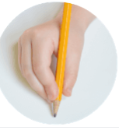I can now show a preference for a dominant hand and use a modified tripod grasp when drawing. | I can use anticlockwise movement and retrace vertical lines. |  | I am beginning to form recognisable letters independently. |  | I am able to demonstrate increasing control during fine motor activities such as threading or using tweezers. |  |  | I can a range of tools including paintbrushes, scissors, cutlery and tape dispensers competently, safely & confidently. |  | I can hold a pencil using a tripod grasp to form recognisable letters, most of which are correctly formed.
Personalisation/  subject links | Feelings  Making friends  PSED-Dinosaur School | Friendship |  | Animals  Countries- hot and cold  Maps- Bear hunt |  | Healthy eating  Growing  Outdoor learning  DT- making cakes |  |  | Transport |  | Animals  Pre Historic- animals from the past  History  Geography- K&U
1  OAK/ELM | Jack and the Jelly Beanstalk  Fiction/Narrative  Sequencing, character description  Audience – pre School  Purpose – To write own stories based on a model  Performance Poetry – Autumn  Audience – to perform to each other (Oak and Elm)  Purpose – To perform a poem orally.  Features of non-fiction texts/posters  Bonfire Night Posters  Audience – whole school  Purpose – To create their own posters/videos to inform each class about staying safe on bonfire night. | A Walk in the Woods  Non-Fiction Letter writing  Audience – Hayley from Bluebell Woods to thank her for our activity day  Purpose – To write a letter to Hayley  Excitable Edgar- Narrative Story – sequence story into beginning, middle and ending  That’s Not My…  Fiction  Narrative – story writing  Purpose – to create a feeling book for pre-school  Audience – pre-school |  | That’s Not My……  Fiction/ Narrative  Audience- Pre School or younger sibling.  Purpose- To create a simple book for Pre-school, using simple sentence and textures.  Animal fact files  Non-fiction (using information learnt from the previous science unit.)  Purpose – to create a fact sheet for our class book  Audience – year 1 class library  Poetry- Book week  Pancake Day - Non Fiction Instructions  Purpose – to write instructions for Zog to make pancakes at dragon school for his friends  (Linked to book week)  Audience – Zog – send them off to Zog at dragon school |  | The magic Paintbrush  Fiction  Story writing/character descriptions  Purpose – to write a story with a clear beginning, middle and ending.  Audience – share with partner from elm/oak  Seasons - Non-Fiction  Purpose – to write simple facts  Audience – to create a game in pairs for their peers to match the fact with the picture |  |  | Grandads Island/ Grandads Camper  Non-fiction  Purpose – to research holidays and activities for information to write a holiday review.  Audience – holiday review to share with year 2  (linked to year 2s Victorian holidays and holidays now)  Grandads Camper – fiction  Compare stories and activities  Fiction  Purpose to write their own travel story  Audience – display |  | Song of the sea – non-fiction/myths  Myths from the UK  e.g.  tooth fairy  loch ness monster  leprechauns  Easter bunny  Research – what is a myth?  Purpose – to write about their favourite myth  Audience – Year 5 (linked to their ancient Greek history unit).
Personalisation/  Subject links | Cross Curricular Links  Science – sorting animals/hot and cold  Geography – continents and Oceans  Geography – Hot and Cold Places North Pole – Penguins | Cross Curricular Links  History –  Oak – WWI  Elm – Great Fire of London  PHSE – Community/Kindness |  | Cross Curricular Links  Science – Space/Materials  PHSE – Friendship  Geography – travelling/The World |  | Cross Curricular Links  Geography – capital cities/United Kingdom  PHSE – right and Wrong  Making Decisions |  |  | Cross Curricular Links  Science – weather and seasonal change  History – change over time  –historical figures/significant people in Hi  PHSE – looking after the environment  DT – making a scarf for the weather/King Charles III for his walks in spring |  | Cross Curricular Links  PHSE – Family/Loss  Geography – Local Area/Mapping and the school grounds
Writing Transcription | Spell:  - words containing each of the 40+ phonemes already taught  - common exception words  - the days of the week  Name the letters of the alphabet:  - naming the letters of the alphabet in order  - using letter names to distinguish between alternative spellings of the same sound  Add prefixes and suffixes:  - using the spelling rule for adding –s or –es as the plural marker for nouns and the third person singular marker for verbs  - using the prefix un–  - using –ing, –ed, –er and –est where no change is needed in the spelling of root words [for example, helping, helped, helper, eating, quicker, quickest]  - apply simple spelling rules and guidance, as listed in English appendix 1  - write from memory simple sentences dictated by the teacher that include words using the GPCs and common exception words taught so far
Writing  Composition | Write sentences by:  - saying out loud what they are going to write about  - composing a sentence orally before writing it  - sequencing sentences to form short narratives  - re-reading what they have written to check that it makes sense  Discuss what they have written with the teacher or other pupils  Read their writing aloud, clearly enough to be heard by their peers and the teacher
Vocabulary, Grammar and Punctuation | Develop their understanding of the concepts by:  - leaving spaces between words  - joining words and joining clauses using ‘and’  - beginning to punctuate sentences using a capital letter and a full stop, question mark or exclamation mark  - using a capital letter for names of people, places, the days of the week, and the personal pronoun ‘I’ |  |  |  | 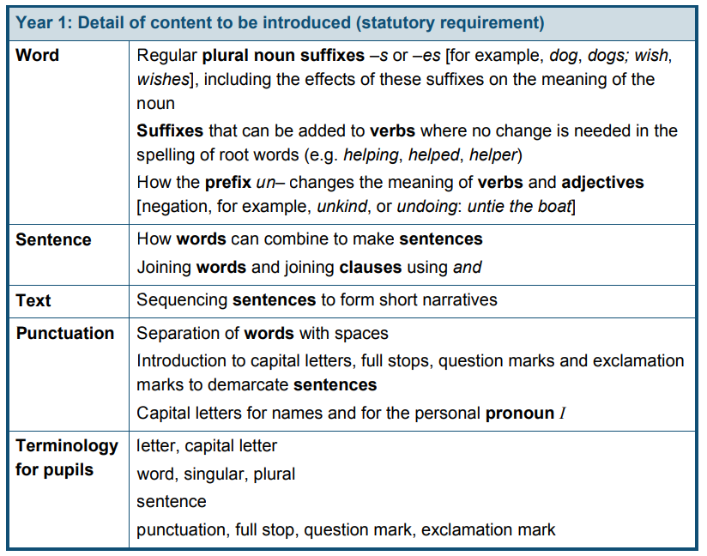
2  YEW | The Crow’s Tale: Narrative- fable  To write a fable to entertain- audience to be decided by children  GPS taught daily across the year | The Owl Who Was Afraid of the Dark: Narrative-adventure story:  To entertain Y1’s  Non-fiction: Christmas Production Programme with synopsis: to inform the audience of the show |  | Stardust: Narrative- story: audience to be decided by children  Helen Sharman/Tim Peake:  non-chronological report: info leaflets  Poetry in Book Week: for a poetry booklet for our class library |  | How to grow a sunflower: Non-fiction- instructions  To inform Eco-councillors  The Lighthouse Keeper and Gracie the Lighthouse Cat: Narrative- stories with a theme: write an adventure story for Cbeebies |  |  | Little Red Reading Hood: Narrative- traditional tale with a twist  Write a new chapter for the author with a different character |  | Mudpuddle Farm: fiction- stories with a familiar setting  Write a new adventure for a new character in the story  The Day the Crayons Quit: Non-fiction-persuasive letter  Write a letter to persuade???  Non-fiction persuasive text:  Farmers’ Market adverts  To inform the wider school family
Personalisation  /subject links | Science: animals including humans | Science: Living things and their habitats |  | Science: animals  History: The UK Space History  DT Lunar Buggy |  | Science: Plants |  |  | Science: animals including humans  PSHE: empathy |  | Science: plants
Writing  Transcription | Spell by:  - segmenting spoken words into phonemes and representing these by graphemes, spelling many correctly  - learning new ways of spelling phonemes for which 1 or more spellings are already known, and learn some words with each spelling, including a few common homophones  - learning to spell common exception words  - learning to spell more words with contracted forms  - learning the possessive apostrophe (singular) [for example, the girl’s book]  - distinguishing between homophones and near-homophones  Add suffixes to spell longer words including –ment, –ness, –ful, –less, –ly  Apply spelling rules and guidance  Write from memory simple sentences dictated by the teacher that include words using the GPCs, common exception words and punctuation taught so far
Writing  Composition | Develop positive attitudes towards and stamina for writing by:  - writing narratives about personal experiences and those of others (real and fictional)  - writing about real events  - writing poetry  - writing for different purposes  Consider what they are going to write before beginning by:  - planning or saying out loud what they are going to write about  - writing down ideas and/or key words, including new vocabulary  - encapsulating what they want to say, sentence by sentence  Make simple additions, revisions and corrections to their own writing by:  - evaluating their writing with the teacher and other pupils  - rereading to check that their writing makes sense and that verbs to indicate time are used correctly and consistently, including verbs in the continuous form  - proofreading to check for errors in spelling, grammar and punctuation (for example, ends of sentences punctuated correctly)  Read aloud what they have written with appropriate intonation to make the meaning clear
Vocabulary, Grammar and Punctuation | Develop their understanding of the concepts by:  - learning how to use both familiar and new punctuation correctly, including full stops, capital letters, exclamation marks, question marks, commas for lists and apostrophes for contracted forms and the possessive (singular)  - learn how to use:  - sentences with different forms: statement, question, exclamation, command  - expanded noun phrases to describe and specify [for example, the blue butterfly]  - the present and past tenses correctly and consistently, including the progressive form  - subordination (using when, if, that, or because) and co-ordination (using or, and, or but)  - the grammar for year 2  - some features of written Standard English  Use and understand the grammatical terminology in discussing their writing |  |  |  |  |  |  | 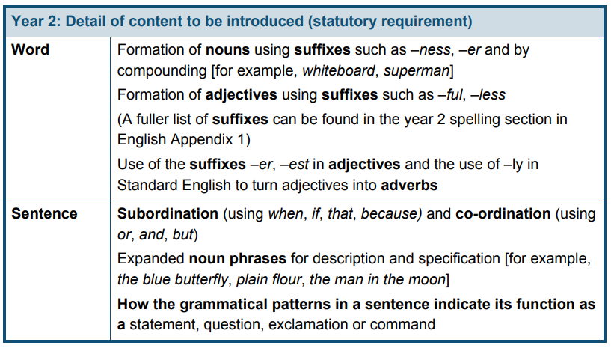  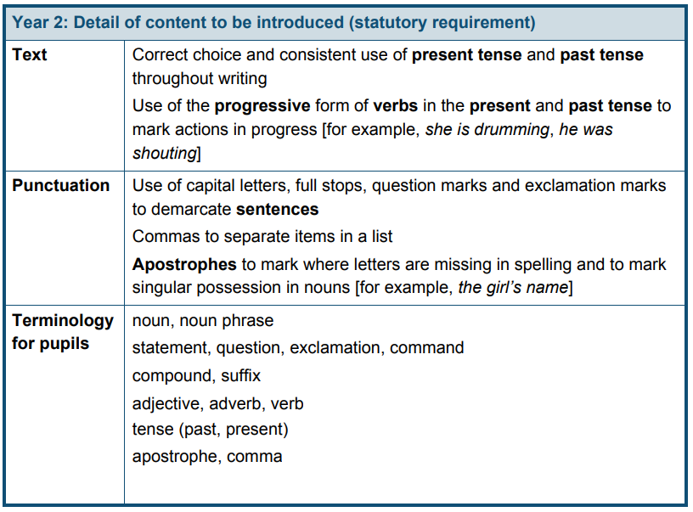
3 | Comedy  (narrative)  “The Incredible Book Eating Boy” & Mr Men  Purpose: Create a new character with a flaw and write a story about his/her transformation.  Audience:  Books shared with KS1 children and kept in class library  Adventure Story  (narrative)  Stone Age Boy & Stig of the Dump  Purpose: Create a story where a character has an adventure with a character from a different time  Audience: KS2 class of choice |  | Winter Wonderland Brochure  (Persuasive writing)  Purpose: Write a brochure/ leaflet enticing visitors to come to a winter theme park of your creation  Audience:  Potential visitors  (Class competition) | Traditional Tale  (narrative)  “The True Story of the Three Little Pigs”  Purpose:  Write twisted tale, based on “The Three Little Pigs”  Audience  Class of choice  Nonsense Verse  (Spike Milligan)  Purpose: Write a rhyming poem to perform  Audience:  Video of performance shared with class/ parents |  |  | Non-Chronological Report  (volcanoes)  Purpose: Write a report to educate future Y3 children about volcanoes  Audience: for Y3 library |  | Suspense Story  (narrative)  “The Wolves in the Walls”  Purpose: Write a frightening suspense story to grip the reader.  Audience: class of choice  Explanation  (lifecycles/ pollination)  Purpose: Create a poster to explain the process of pollination  Audience: to show Y2 children & for display | Romance Story  (narrative)  Purpose: Write a romance story about a character looking for his/ her true love.  Audience: Share with class of choice
Personalisation/  Subject links | Stone Age (history) |  | Christmas | Poetry Week |  |  | Volcanoes (geography) |  | Science: plants
Writing  Transcription | - use further prefixes and suffixes and understand how to add them  - spell further homophones  - spell words that are often misspelt  - place the possessive apostrophe accurately in words with regular plurals [for example, girls’, boys’] and in words with irregular plurals [for example, children’s]  - use the first 2 or 3 letters of a word to check its spelling in a dictionary  - write from memory simple sentences, dictated by the teacher, that include words and punctuation taught so far
Writing  Composition | Plan their writing by:  - discussing writing similar to that which they are planning to write in order to understand and learn from its structure, vocabulary and grammar  - discussing and recording ideas  Draft and write by:  - composing and rehearsing sentences orally (including dialogue), progressively building a varied and rich vocabulary and an increasing range of sentence structures  - organising paragraphs around a theme  - in narratives, creating settings, characters and plot  - in non-narrative material, using simple organisational devices [for example, headings and sub-headings]  Evaluate and edit by:  - assessing the effectiveness of their own and others’ writing and suggesting improvements  - proposing changes to grammar and vocabulary to improve consistency, including the accurate use of pronouns in sentences  Proofread for spelling and punctuation errors  Read their own writing aloud to a group or the whole class, using appropriate intonation and controlling the tone and volume so that the meaning is clear
Vocabulary, Grammar and Punctuation | Develop their understanding of the concepts by:  - extending the range of sentences with more than one clause by using a wider range of conjunctions, including: when, if, because, although  - using the present perfect form of verbs in contrast to the past tense  - choosing nouns or pronouns appropriately for clarity and cohesion and to avoid repetition  - using conjunctions, adverbs and prepositions to express time and cause  - using fronted adverbials  - learning the grammar for years 3 and 4  Indicate grammatical and other features by:  - using commas after fronted adverbials  - indicating possession by using the possessive apostrophe with plural nouns  - using and punctuating direct speech  Use and understand the grammatical terminology accurately and appropriately when discussing their writing and reading |  |  |  |  |  |  | 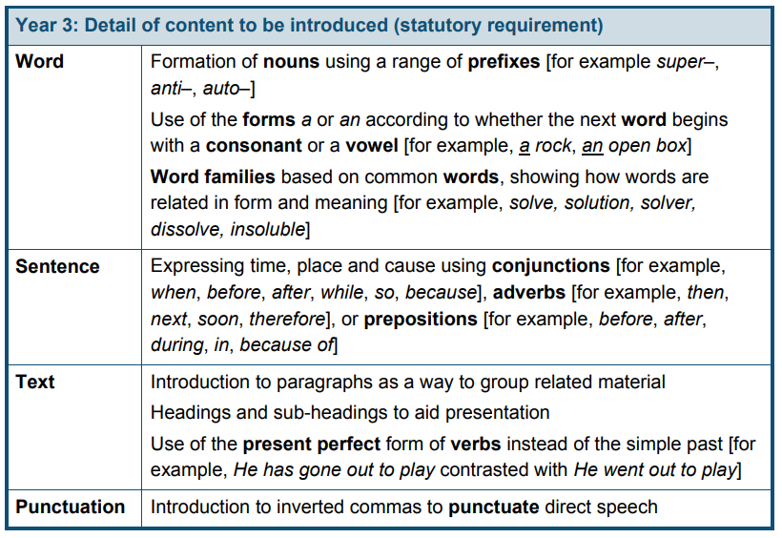  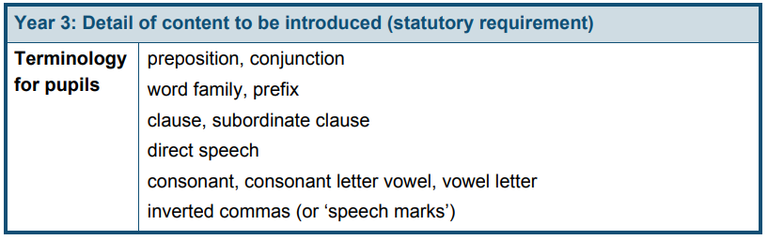
4 | AUT 1  A medal for Leroy  Narrative  Traditional tales  Princess and Pea  Audience: Parents / family members to showcase our writing at the start of Year 4.  Purpose: To create a new ending to a traditional story.  Science Fiction  The Iron Man  Audience: A friend in class to help with target setting.  Purpose: To create a continuation of the plot.  GPS |  | AUT 2  The Boy at the back of the class  Play script  Traditional Tale links  Audience: The whole school via Dojos. (Video performances)  Purpose: To create and perform an extract of a play to others.  GPS | SRING 1  Max and the Millions  Non-Fiction  Newspaper Report  Audience: Lancashire Evening Post.  Purpose: To write a newspaper article about the events at Manor Road.  Narrative  Mystery  The Whale  Audience: Mrs Marshall and Mrs Foulds.  Purpose: To create a short mystery story.  Poetry  Audience: Whole school.  Purpose: To perform a poem aloud.  GPS |  |  | SPRING 2  Aquila  Non Fiction  The Water Cycle Non-Chronological Report  Audience: Local library for display in NF area.  Purpose: To create a factual report about the Water Cycle.  Narrative  Adventure  The BFG  Audience: A friend or family member of your choice.  Purpose: To recreate the ending of an adventure story.  GPS |  | SUMMER 1  The Magic Faraway Tree  Non Fiction  The Water Cycle Non-Chronological Report  Audience: Local library for display in NF area.  Purpose: To create a factual report about the Water Cycle.  Narrative  Fantasy  The Magic Faraway Tree  Audience: Jacqueline Wilson  Purpose: To write an ‘Exciting Rescue’ chapter.  GPS | SUMMER 2  Firework Maker’s Daughter  Non –Fiction  Persuasive writing  Adverts for healthy eating  Audience: School governors and SLT.  Purpose: To create healthy eating adverts to encourage everyone in school to eat well and reduce single use plastic.  GPS
Personalisation/  Subject links | Science  Geography  Science  History | Science  Geography  Book Week |  | Geography  Science |  | Science  Geography  Science  History |  |  | Science  Geography  Book Week |  | Geography  Science
Writing  Transcription | - use further prefixes and suffixes and understand how to add them  - spell further homophones  - spell words that are often misspelt  - place the possessive apostrophe accurately in words with regular plurals [for example, girls’, boys’] and in words with irregular plurals [for example, children’s]  - use the first 2 or 3 letters of a word to check its spelling in a dictionary  write from memory simple sentences, dictated by the teacher, that include words and punctuation taught so far
Writing  Composition | Plan their writing by:  - discussing writing similar to that which they are planning to write in order to understand and learn from its structure, vocabulary and grammar  - discussing and recording ideas  Draft and write by:  - composing and rehearsing sentences orally (including dialogue), progressively building a varied and rich vocabulary and an increasing range of sentence structures  - organising paragraphs around a theme  - in narratives, creating settings, characters and plot  - in non-narrative material, using simple organisational devices [for example, headings and sub-headings]  Evaluate and edit by:  - assessing the effectiveness of their own and others’ writing and suggesting improvements  - proposing changes to grammar and vocabulary to improve consistency, including the accurate use of pronouns in sentences  Proofread for spelling and punctuation errors  Read their own writing aloud to a group or the whole class, using appropriate intonation and controlling the tone and volume so that the meaning is clear
Vocabulary, Grammar and Punctuation | Develop their understanding of the concepts by:  - extending the range of sentences with more than one clause by using a wider range of conjunctions, including: when, if, because, although  - using the present perfect form of verbs in contrast to the past tense  - choosing nouns or pronouns appropriately for clarity and cohesion and to avoid repetition  - using conjunctions, adverbs and prepositions to express time and cause  - using fronted adverbials  - learning the grammar for years 3 and 4  Indicate grammatical and other features by:  - using commas after fronted adverbials  - indicating possession by using the possessive apostrophe with plural nouns  - using and punctuating direct speech  Use and understand the grammatical terminology accurately and appropriately when discussing their writing and reading |  |  |  |  |  |  | 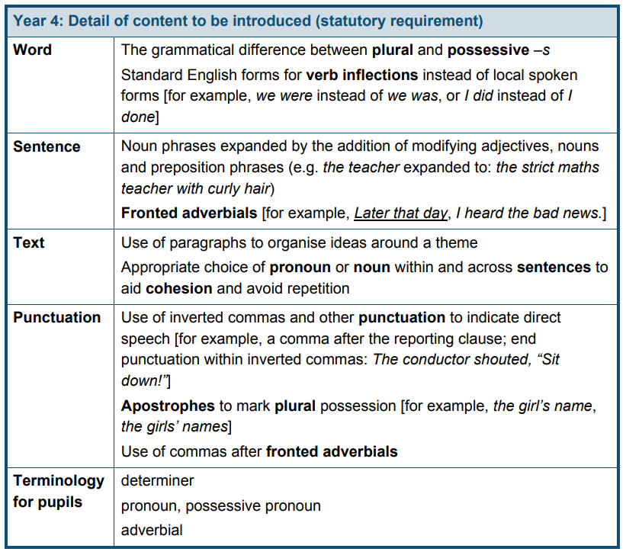
5 | Gorilla – Story (narrative)  Audience: Year 3.  Purpose: To write a story for younger children  Non-Chronological Report (fictional animal)  Audience: Year 5/6  Purpose: To create an anthology of mythical creatures(to be used/viewed when covering Greeks in Aut2) | Oliver Twist  Audience:  Purpose:  Non-Chronological Report (Science link – zoo animal)  Audience: Take to the zoo on the trip/zookeepers  Purpose: Visit to the zoo |  | Ice Palace– Novel as a Theme (Fantasy)  Writing outcomes will include: poetry, instructions, recount, information texts, narrative ending.  Playscripts (Mayans Play in a Day)  Each has their own individual purpose |  | ‘The Magic Box’  Audience: Display in the local library  Purpose: Poetry anthology  Book Week  Perform a rap/poetry to EYFS  ‘The Highwayman’  (Narrative poetry/ writing outcome is a newspaper report)  Audience: Post to Julia Donaldson  Purpose: To create a newspaper report based on The Highway Rat |  |  | Finish Highwayman unit  School uniform/homework – (persuasive letter)  Audience: Mrs Marshall/ The Governors  Purpose: To write to the school to ask to wear slippers around school!  The Nowhere Emporium  Audience:  Purpose: |  | Plastic Pollution  Audience:  Purpose:
Personalisation/  Subject links | Links with science (living things and their habitats)  . | Links with science (animals including humans and the Blackpool Zoo trip)  Y5 space unit. |  | Links with PALS Playground leader training  Links with collage – complete independent piece based on Autumn’s art unit  Links with drama and debates (debates also covered in History – Greek unit) |  | Links with drama/role play  Links with performance poetry/music  Links with PSHE and knowing wrong from right. |  |  | Links to debate |  | Links with art, drama, mental health and wellbeing
Writing  Transcription | - use further prefixes and suffixes and understand the guidance for adding them  - spell some words with ‘silent’ letters [for example, knight, psalm, solemn]  - continue to distinguish between homophones and other words which are often confused  - use knowledge of morphology and etymology in spelling and understand that the spelling of some words needs to be learnt specifically  - use dictionaries to check the spelling and meaning of words  - use the first 3 or 4 letters of a word to check spelling, meaning or both of these in a dictionary  - use a thesaurus
Writing  Composition | Plan their writing by:  - identifying the audience for and purpose of the writing, selecting the appropriate form and using other similar writing as models for their own  - noting and developing initial ideas, drawing on reading and research where necessary  - in writing narratives, considering how authors have developed characters and settings in what pupils have read, listened to or seen performed  Draft and write by:  - selecting appropriate grammar and vocabulary, understanding how such choices can change and enhance meaning  - in narratives, describing settings, characters and atmosphere and integrating dialogue to convey character and advance the action  - précising longer passages  - using a wide range of devices to build cohesion within and across paragraphs  - using further organisational and presentational devices to structure text and to guide the reader [for example, headings, bullet points, underlining]  Evaluate and edit by:  - assessing the effectiveness of their own and others’ writing  - proposing changes to vocabulary, grammar and punctuation to enhance effects and clarify meaning  - ensuring the consistent and correct use of tense throughout a piece of writing  - ensuring correct subject and verb agreement when using singular and plural, distinguishing between the language of speech and writing and choosing the appropriate register  Proofread for spelling and punctuation errors  Perform their own compositions, using appropriate intonation, volume, and movement so that meaning is clear
Vocabulary, Grammar and Punctuation | Develop their understanding of the concepts by:  - recognising vocabulary and structures that are appropriate for formal speech and writing, including subjunctive forms  - using passive verbs to affect the presentation of information in a sentence  - using the perfect form of verbs to mark relationships of time and cause  - using expanded noun phrases to convey complicated information concisely  - using modal verbs or adverbs to indicate degrees of possibility  - using relative clauses beginning with who, which, where, when, whose, that or with an implied (ie omitted) relative pronoun  - learning the grammar for years 5 and 6  Indicate grammatical and other features by:  - using commas to clarify meaning or avoid ambiguity in writing  - using hyphens to avoid ambiguity  - using brackets, dashes or commas to indicate parenthesis  - using semicolons, colons or dashes to mark boundaries between independent clauses  - using a colon to introduce a list  - punctuating bullet points consistently  Use and understand the grammatical terminology accurately and appropriately in discussing their writing and reading |  |  |  |  |  |  | 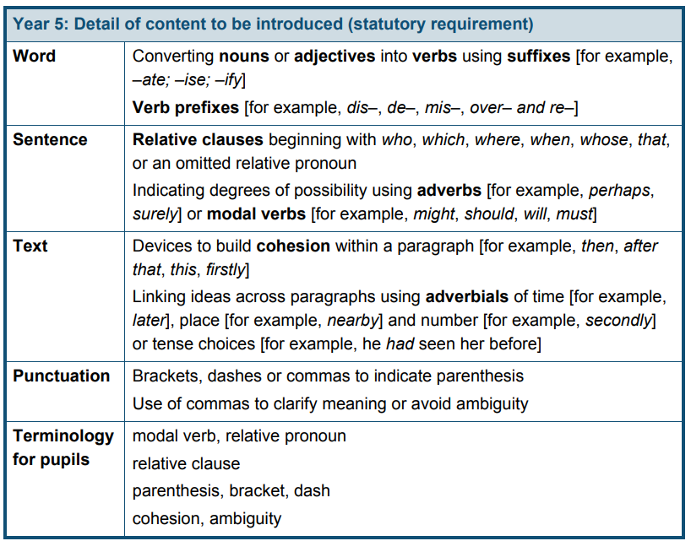
6 | Narrative Story: Varmints by Marc Craste  Audience:  Purpose:  Non-fiction  Newspaper Report: School Newspaper | Historical Narrative: Letters from the Lighthouse: Emma Carroll  Non-fiction Persuasive Letter:  To Mrs Marshall |  | Narrative Romance:  Paperman by Disney  Non-fiction Postcard:  Postcard from Prison |  | Narrative Horror: A Monster Calls by Patrick Ness  Poetry – Book Week  The Listeners  What I Love About School |  |  | Last Push Pack: Wonder by R. J. Palacio  Narrative  Biography  Discussion and Debate  Poetry |  | Narrative Traditional Tale:  Hansel and Gretel by Neil Gaiman
Personalisation/  Subject links |  | Letters from the Lighthouse links with our History topic on WW2. |  | The Anglo-Saxon Battle links with our history topic of the Vikings |  |  |  |  | Newspaper links to our ‘reading for pleasure’ book, Off Side.
Writing  Transcription | - use further prefixes and suffixes and understand the guidance for adding them  - spell some words with ‘silent’ letters [for example, knight, psalm, solemn]  - continue to distinguish between homophones and other words which are often confused  - use knowledge of morphology and etymology in spelling and understand that the spelling of some words needs to be learnt specifically, as listed in English appendix 1  - use dictionaries to check the spelling and meaning of words  - use the first 3 or 4 letters of a word to check spelling, meaning or both of these in a dictionary  - use a thesaurus
Writing  Composition | Plan their writing by:  - identifying the audience for and purpose of the writing, selecting the appropriate form and using other similar writing as models for their own  - noting and developing initial ideas, drawing on reading and research where necessary  - in writing narratives, considering how authors have developed characters and settings in what pupils have read, listened to or seen performed  Draft and write by:  - selecting appropriate grammar and vocabulary, understanding how such choices can change and enhance meaning  - in narratives, describing settings, characters and atmosphere and integrating dialogue to convey character and advance the action  - précising longer passages  - using a wide range of devices to build cohesion within and across paragraphs  - using further organisational and presentational devices to structure text and to guide the reader [for example, headings, bullet points, underlining]  Evaluate and edit by:  - assessing the effectiveness of their own and others’ writing  - proposing changes to vocabulary, grammar and punctuation to enhance effects and clarify meaning  - ensuring the consistent and correct use of tense throughout a piece of writing  - ensuring correct subject and verb agreement when using singular and plural, distinguishing between the language of speech and writing and choosing the appropriate register  Proofread for spelling and punctuation errors  Perform their own compositions, using appropriate intonation, volume, and movement so that meaning is clear
Vocabulary, Grammar and Punctuation | Develop their understanding of the concepts by:  - recognising vocabulary and structures that are appropriate for formal speech and writing, including subjunctive forms  - using passive verbs to affect the presentation of information in a sentence  - using the perfect form of verbs to mark relationships of time and cause  - using expanded noun phrases to convey complicated information concisely  - using modal verbs or adverbs to indicate degrees of possibility  - using relative clauses beginning with who, which, where, when, whose, that or with an implied (ie omitted) relative pronoun  - learning the grammar for years 5 and 6  Indicate grammatical and other features by:  - using commas to clarify meaning or avoid ambiguity in writing  - using hyphens to avoid ambiguity  - using brackets, dashes or commas to indicate parenthesis  - using semicolons, colons or dashes to mark boundaries between independent clauses  - using a colon to introduce a list  - punctuating bullet points consistently  Use and understand the grammatical terminology accurately and appropriately in discussing their writing and reading |  |  |  |  |  |  | 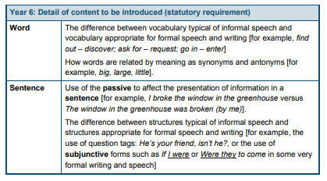  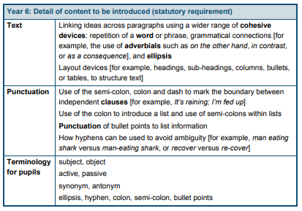

Narrative
Adventure
Story
Traditional Tale
Science Fiction
Mystery
Fantasy
Romance
Ghost Story

Non-Fiction
Recount
Post card
Biography
Persuasive speech
Newspaper Report
Speech
Journal
Diary
Instructions
Non-Chron Report
Explanation
Playscript

Poetry
Rap
Humerous
List
Acrostic

