LONG TERM PLAN
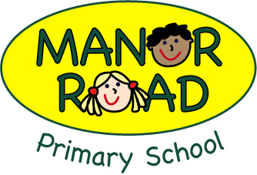

English 2021-2022

Year | Autumn 1 | Autumn 2 | Spring 1 |  | Spring 2 |  | Summer 1 | Summer 2
Pre-School Texts
Pre- School | On entry assessments  Mark making  Colouring  Beginning to make random marks on paper and say what it is | Knows that print carries meaning and in English, is read from left to right and top to bottom | Makes representational drawings including features which can be recognised by others |  | Begins to imitate writing by making continuous lines of shapes and symbols from left to right |  | Can copy and write some or all letters from name  Begins to write single letter sounds (SATPIN) | Begins to write single letter sounds for all sounds taught  Can write some simple cvc words using sounds taught  Introduce children to phase 2 tricky words in writing as well as reading
Pre-School Fine Motor | I can create lines and circles pivoting from the shoulder and elbow using large chalk | I can manipulate a range of tools and equipment in one hand, including paintbrushes, toothbrushes, scarves or ribbons | I am able to demonstrate increasing control during fine motor activities such as a pincer grasp to pick up objects |  | I can use loop scissors to make snips in paper or follow a simple line |  | 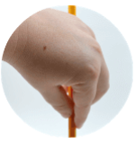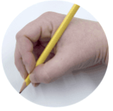  I can use a pronate grasp or a quadupod grasp with good control when holding pencils to draw lines and create | I am beginning to learn how to use a knife and fork
Year | Autumn 1 | Autumn 2 | Spring 1 |  | Spring 2 |  | Summer 1 | Summer 2
Reception Texts  Bold texts are TWS | Stick Man  The Smartest Giant  Giraffes’s can’t dance  Ruby’s Worry  Narrative Story  Funny Bones -various  The Big Book of Families  Pete the Cat  Room on the Broom | The Jolly Postman  Goldilocks  Farmer Duck  Hansel & Gretal  The Ugly Duckling  Christmas Story / Nativityish  The Rainbow Fish  Narrative Story  Pig’s might fly  Penguins | The Emperors Egg  We’re going on a Bear Hunt  Narrative Adventure  The Very Hungry Caterpillar  Aghh Spider!  Tiger who came to tea  Handa’s Surprise  Narrative Story  Poetry in Book Week |  | The Tiny Seed  Oliver’s Vegetables  Jack and the jelly Beanstalk  One Plastic Bag  Jasper’s Beanstalk  DTree, Seasons come and seasons go  A stroll through the seasons  Sam and Dave Dig a Big Hole  Narrative Story  Hole  How to make a chocolate mud cake  Non-Fiction Instructions |  | The Snail and the Whale  The Naughty Bus  Mr. Gumpy’s Outing  The Train Ride  Bob, The Man on the Moon  Beegu  Oi! Get off my train!  I Wanna Iguana | Dinosaur Dinners non fiction  Harry and his bucketful of dinosaurs  The dinosaur that pooped a planet  If Sharks Disappeared  Non-Fiction Report
Reception | Assessments/ on entry – starting Phase 2 phonics  Writing single letters  Writing some simple satpin cvc words | Name writing  Labelling  Initial sounds  Retelling stories in the writing area  Sequencing  Write a simple sentence with Phase 2 sounds | Writing tricky words I go no to into the  Writing cvc words in sentences  Writing some cvcc and ccvc words  Guided writing sentences |  | Creating own story maps  Writing captions and labels with some Phase 3 sounds  Writing simple sentences  Writing instructions  Write 2 sentences  Attempt full stops and capital letters in writing |  | Writing lists  Writing for a purpose in provision using sounds learnt so far  Plausible attempts at all words  Beginning to use finger spaces  Form lower case letters correctly | ELG  Write recognisable letters, most of which are  correctly formed.  Spell words by identifying sounds in them and  representing the sounds with a letter or letters.  Write simple phrases and sentences that can be  read by others.  Use adjectives to enhance writing (noticing lens)  Form most capital letters correctly  Use some alternative spellings in their writing (Phase 5 beginning)
Reception  Fine Motor | 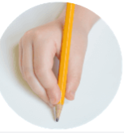I can now show a preference for a dominant hand and use a modified tripod grasp when drawing. | I can use anticlockwise movement and retrace vertical lines. | I am beginning to form recognisable letters independently. |  | I am able to demonstrate increasing control during fine motor activities such as threading or using tweezers. |  | I can a range of tools including paintbrushes, scissors, cutlery and tape dispensers competently, safely & confidently. | I can hold a pencil using a tripod grasp to form recognisable letters, most of which are correctly formed.
Personalisation/  subject links | Feelings  Making friends  PSED-Dinosaur School | Friendship | Animals  Countries- hot and cold  Maps- Bear hunt |  | Healthy eating  Growing  Outdoor learning  DT- making cakes |  | Transport | Animals  Pre Historic- animals from the past  History  Geography- K&U
1  OAK/ELM | Last Stop on Market street- Narrative- Story  SPAG | Our Walk in the Woods- Non Fiction- Recount  Excitable Edgar- Narrative Story  SPAG | Way back home- Narrative- Science fiction story  Poetry- Book week  Pancake- Non Fiction Instructions  SPAG |  | The Queens Hat- Fiction Narrative Adventure Story  On Safari- Non-Fiction Travel Journal  SPAG |  | Song Of the Sea- Narrative Myth  Bold Women in Black History- Non Fiction Biography  SPAG | Grandads Island-Narrative adventure story  SPAG
Personalisation/  Subject links | Cross Curricular Links  Science – sorting animals/hot and cold  Geography – continents and Oceans  Geography – Hot and Cold Places North Pole – Penguins | Cross Curricular Links  History –  Oak – WWI  Elm – Great Fire of London  PHSE – Community/Kindness | Cross Curricular Links  Science – Space/Materials  PHSE – Friendship  Geography – travelling/The World |  | Cross Curricular Links  Geography – capital cities/United Kingdom  PHSE – right and Wrong  Making Decisions |  | Cross Curricular Links  Science – The Human Body/Senses  History –  Oak – Mary Seacole  Elm – Florence Nightingale  PHSE – physical Health (sun safety, food and exercise)  DT – Food (design and make)  History – historical figures/significant people in History | Cross Curricular Links  PHSE – Family/Loss  Geography – Local Area/Mapping and the school grounds
Writing Transcription | Spell:  - words containing each of the 40+ phonemes already taught  - common exception words  - the days of the week  Name the letters of the alphabet:  - naming the letters of the alphabet in order  - using letter names to distinguish between alternative spellings of the same sound  Add prefixes and suffixes:  - using the spelling rule for adding –s or –es as the plural marker for nouns and the third person singular marker for verbs  - using the prefix un–  - using –ing, –ed, –er and –est where no change is needed in the spelling of root words [for example, helping, helped, helper, eating, quicker, quickest]  - apply simple spelling rules and guidance, as listed in English appendix 1  - write from memory simple sentences dictated by the teacher that include words using the GPCs and common exception words taught so far
Writing  Composition | Write sentences by:  - saying out loud what they are going to write about  - composing a sentence orally before writing it  - sequencing sentences to form short narratives  - re-reading what they have written to check that it makes sense  Discuss what they have written with the teacher or other pupils  Read their writing aloud, clearly enough to be heard by their peers and the teacher
Vocabulary, Grammar and Punctuation | Develop their understanding of the concepts by:  - leaving spaces between words  - joining words and joining clauses using ‘and’  - beginning to punctuate sentences using a capital letter and a full stop, question mark or exclamation mark  - using a capital letter for names of people, places, the days of the week, and the personal pronoun ‘I’ |  |  | 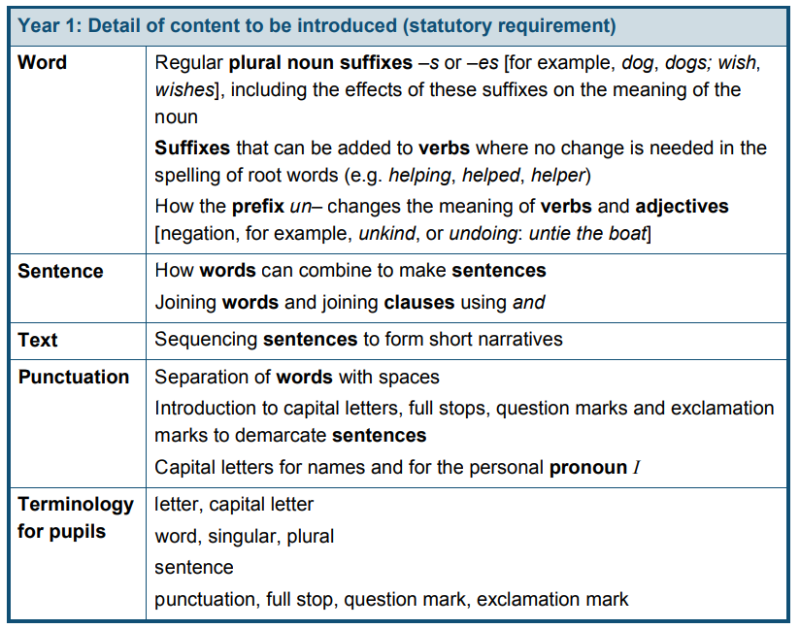
2  YEW | The Crow’s Tale: Narrative- fable  Hibernation: Non-fiction- non-chronological report  SPAG | The Owl Who Was Afraid of the Dark: Narrative-adventure  SPAG | Stardust: Narrative- story  How to Make a Bird Feeder: Non-fiction-instruction  Poetry in Book Week  SPAG |  | Plants: Non-fiction- information text  SPAG |  | Little Red Reading Hood: Narrative- traditional tale with a twist  The Day the Crayons Quit: Non-fiction-persuasive letter  SPAG | The Marvellous Fluffy Squishy Itty Bitty: Narrative- story  SPAG
Personalisation  /subject links | Science: animals including humans | Science: Living things and their habitats | Science: materials  History: The UK Space History |  | Art: Monet’s Gardens at Giverny  Science: Plants |  | Science: animals including humans | PSHE: Growing and changing
Writing  Transcription | Spell by:  - segmenting spoken words into phonemes and representing these by graphemes, spelling many correctly  - learning new ways of spelling phonemes for which 1 or more spellings are already known, and learn some words with each spelling, including a few common homophones  - learning to spell common exception words  - learning to spell more words with contracted forms  - learning the possessive apostrophe (singular) [for example, the girl’s book]  - distinguishing between homophones and near-homophones  Add suffixes to spell longer words including –ment, –ness, –ful, –less, –ly  Apply spelling rules and guidance  Write from memory simple sentences dictated by the teacher that include words using the GPCs, common exception words and punctuation taught so far
Writing  Composition | Develop positive attitudes towards and stamina for writing by:  - writing narratives about personal experiences and those of others (real and fictional)  - writing about real events  - writing poetry  - writing for different purposes  Consider what they are going to write before beginning by:  - planning or saying out loud what they are going to write about  - writing down ideas and/or key words, including new vocabulary  - encapsulating what they want to say, sentence by sentence  Make simple additions, revisions and corrections to their own writing by:  - evaluating their writing with the teacher and other pupils  - rereading to check that their writing makes sense and that verbs to indicate time are used correctly and consistently, including verbs in the continuous form  - proofreading to check for errors in spelling, grammar and punctuation (for example, ends of sentences punctuated correctly)  Read aloud what they have written with appropriate intonation to make the meaning clear
Vocabulary, Grammar and Punctuation | Develop their understanding of the concepts by:  - learning how to use both familiar and new punctuation correctly, including full stops, capital letters, exclamation marks, question marks, commas for lists and apostrophes for contracted forms and the possessive (singular)  - learn how to use:  - sentences with different forms: statement, question, exclamation, command  - expanded noun phrases to describe and specify [for example, the blue butterfly]  - the present and past tenses correctly and consistently, including the progressive form  - subordination (using when, if, that, or because) and co-ordination (using or, and, or but)  - the grammar for year 2  - some features of written Standard English  Use and understand the grammatical terminology in discussing their writing |  |  |  |  | 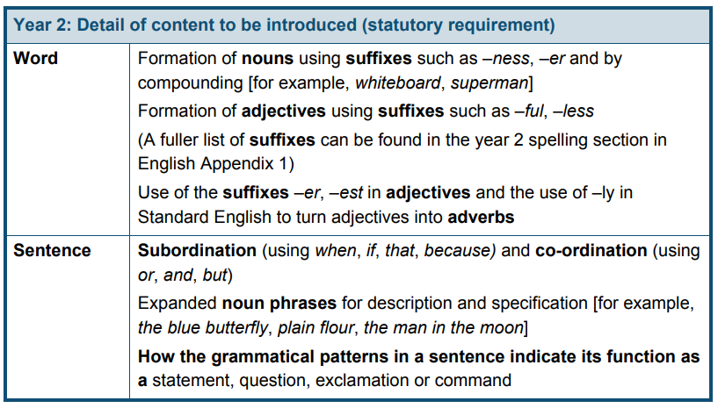  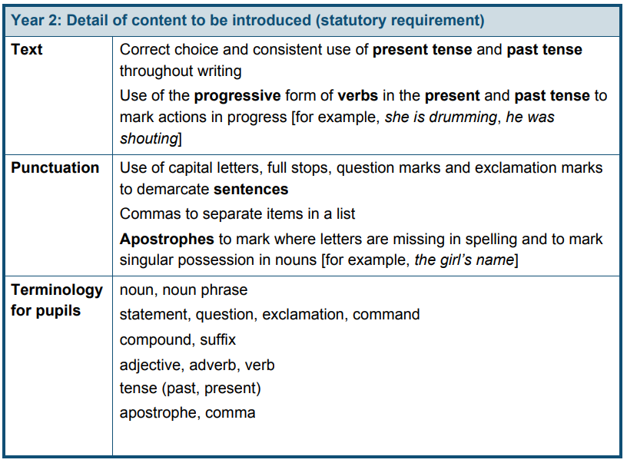
3 | Comedy  Story  Persuasive Text  SPAG | Traditional Tale  Explanation  Romance  SPAG | Suspense  Non-Chronological Report  Adventure  Poetry in Book Week  SPAG |  | Comedy  Story  Persuasive Text  SPAG |  | Traditional Tale  Explanation  Romance  SPAG | Suspense  Non-Chronological Report  Adventure  SPAG
Personalisation/  Subject links | Stone Age (history) | Rocks, Earthquakes and Volcanoes (science & geography) | Roman Britain (history) |  | Stone Age (history) |  | Rocks, Earthquakes and Volcanoes (science & geography) | Roman Britain (history)
Writing  Transcription | - use further prefixes and suffixes and understand how to add them  - spell further homophones  - spell words that are often misspelt  - place the possessive apostrophe accurately in words with regular plurals [for example, girls’, boys’] and in words with irregular plurals [for example, children’s]  - use the first 2 or 3 letters of a word to check its spelling in a dictionary  - write from memory simple sentences, dictated by the teacher, that include words and punctuation taught so far
Writing  Composition | Plan their writing by:  - discussing writing similar to that which they are planning to write in order to understand and learn from its structure, vocabulary and grammar  - discussing and recording ideas  Draft and write by:  - composing and rehearsing sentences orally (including dialogue), progressively building a varied and rich vocabulary and an increasing range of sentence structures  - organising paragraphs around a theme  - in narratives, creating settings, characters and plot  - in non-narrative material, using simple organisational devices [for example, headings and sub-headings]  Evaluate and edit by:  - assessing the effectiveness of their own and others’ writing and suggesting improvements  - proposing changes to grammar and vocabulary to improve consistency, including the accurate use of pronouns in sentences  Proofread for spelling and punctuation errors  Read their own writing aloud to a group or the whole class, using appropriate intonation and controlling the tone and volume so that the meaning is clear
Vocabulary, Grammar and Punctuation | Develop their understanding of the concepts by:  - extending the range of sentences with more than one clause by using a wider range of conjunctions, including: when, if, because, although  - using the present perfect form of verbs in contrast to the past tense  - choosing nouns or pronouns appropriately for clarity and cohesion and to avoid repetition  - using conjunctions, adverbs and prepositions to express time and cause  - using fronted adverbials  - learning the grammar for years 3 and 4  Indicate grammatical and other features by:  - using commas after fronted adverbials  - indicating possession by using the possessive apostrophe with plural nouns  - using and punctuating direct speech  Use and understand the grammatical terminology accurately and appropriately when discussing their writing and reading |  |  |  |  | 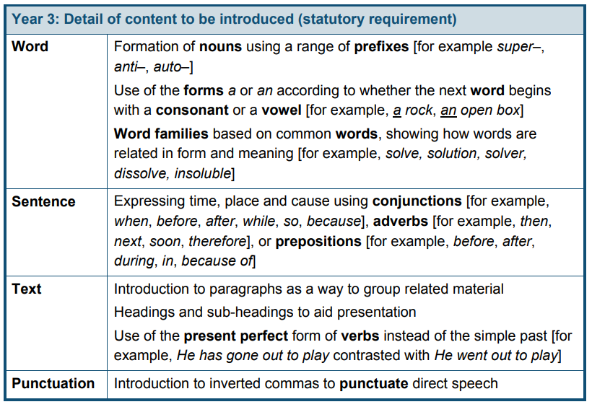  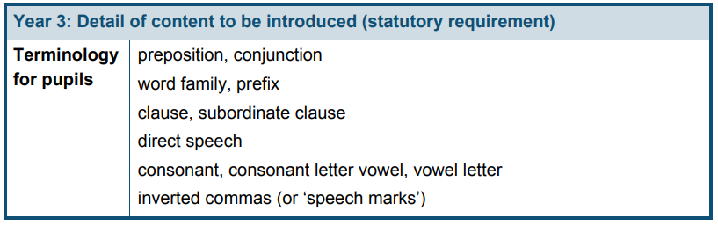
4 | AUTUMN  Narrative  Traditional Tales  Narrative  Science Fiction  Play script  SPAG  : |  | SPRING  Non-Fiction  Newspaper Report  Narrative  Mystery  Non-Fiction  Script for Factual Tour  BOOK WEEK: Poetry  SPAG |  |  |  | SUMMER  Narrative  Adventure  Narrative  Fantasy  Non –Fiction  Persuasive writing  SPAG
Personalisation/  Subject links | Science  Geography  Science  History | Science  Geography  Book Week | Geography  Science |  | Science  Geography  Science  History |  | Science  Geography  Book Week | Geography  Science
Writing  Transcription | - use further prefixes and suffixes and understand how to add them  - spell further homophones  - spell words that are often misspelt  - place the possessive apostrophe accurately in words with regular plurals [for example, girls’, boys’] and in words with irregular plurals [for example, children’s]  - use the first 2 or 3 letters of a word to check its spelling in a dictionary  write from memory simple sentences, dictated by the teacher, that include words and punctuation taught so far
Writing  Composition | Plan their writing by:  - discussing writing similar to that which they are planning to write in order to understand and learn from its structure, vocabulary and grammar  - discussing and recording ideas  Draft and write by:  - composing and rehearsing sentences orally (including dialogue), progressively building a varied and rich vocabulary and an increasing range of sentence structures  - organising paragraphs around a theme  - in narratives, creating settings, characters and plot  - in non-narrative material, using simple organisational devices [for example, headings and sub-headings]  Evaluate and edit by:  - assessing the effectiveness of their own and others’ writing and suggesting improvements  - proposing changes to grammar and vocabulary to improve consistency, including the accurate use of pronouns in sentences  Proofread for spelling and punctuation errors  Read their own writing aloud to a group or the whole class, using appropriate intonation and controlling the tone and volume so that the meaning is clear
Vocabulary, Grammar and Punctuation | Develop their understanding of the concepts by:  - extending the range of sentences with more than one clause by using a wider range of conjunctions, including: when, if, because, although  - using the present perfect form of verbs in contrast to the past tense  - choosing nouns or pronouns appropriately for clarity and cohesion and to avoid repetition  - using conjunctions, adverbs and prepositions to express time and cause  - using fronted adverbials  - learning the grammar for years 3 and 4  Indicate grammatical and other features by:  - using commas after fronted adverbials  - indicating possession by using the possessive apostrophe with plural nouns  - using and punctuating direct speech  Use and understand the grammatical terminology accurately and appropriately when discussing their writing and reading |  |  |  |  | 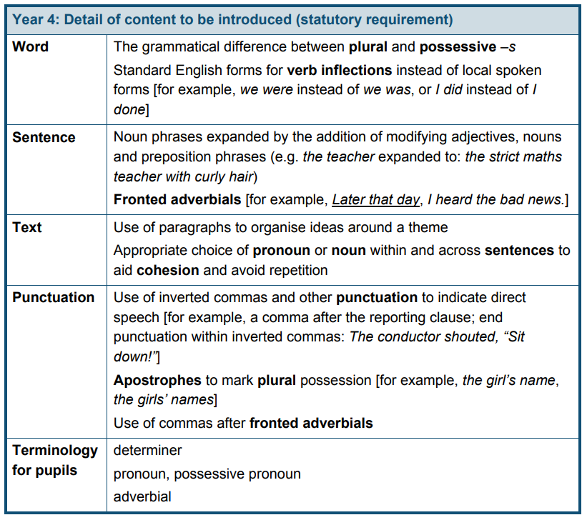
5 | Narrative: Adventure  Narrative: Fantasy  SPAG | Non-Fiction: Journal  SPAG | Narrative: story  Narrative: Mystery  Poetry in Book Week  SPAG |  | Non-Fiction: Speech  Poetry: narrative poem  SPAG |  | Narrative Story  Non-Fiction: Non-chronological report  SPAG | Non-fiction: persuasive letter  SPAG
Personalisation/  Subject links | Links with science and going to the Moon and space travel.  Links in both with PSHE and mental health. | Links with science and space travel. Links with PSHE emotional health and wellbeing. | Links with younger children or siblings and reading stories to them. Links with looking after objects.  Links with The Greatest Showman which is popular with the class. |  | Links with geography and science and looking after the environment and animals. Links with religious education and caring for the world.  Links with science. Plastic pollution is very current.  Links with PSHE and not breaking the law. What is the right thing to do? |  | Links in both with PSHE and mental health/ bereavement.  Links with science – animals. | Links with geography: fair trade and food miles.
Writing  Transcription | - use further prefixes and suffixes and understand the guidance for adding them  - spell some words with ‘silent’ letters [for example, knight, psalm, solemn]  - continue to distinguish between homophones and other words which are often confused  - use knowledge of morphology and etymology in spelling and understand that the spelling of some words needs to be learnt specifically  - use dictionaries to check the spelling and meaning of words  - use the first 3 or 4 letters of a word to check spelling, meaning or both of these in a dictionary  - use a thesaurus
Writing  Composition | Plan their writing by:  - identifying the audience for and purpose of the writing, selecting the appropriate form and using other similar writing as models for their own  - noting and developing initial ideas, drawing on reading and research where necessary  - in writing narratives, considering how authors have developed characters and settings in what pupils have read, listened to or seen performed  Draft and write by:  - selecting appropriate grammar and vocabulary, understanding how such choices can change and enhance meaning  - in narratives, describing settings, characters and atmosphere and integrating dialogue to convey character and advance the action  - précising longer passages  - using a wide range of devices to build cohesion within and across paragraphs  - using further organisational and presentational devices to structure text and to guide the reader [for example, headings, bullet points, underlining]  Evaluate and edit by:  - assessing the effectiveness of their own and others’ writing  - proposing changes to vocabulary, grammar and punctuation to enhance effects and clarify meaning  - ensuring the consistent and correct use of tense throughout a piece of writing  - ensuring correct subject and verb agreement when using singular and plural, distinguishing between the language of speech and writing and choosing the appropriate register  Proofread for spelling and punctuation errors  Perform their own compositions, using appropriate intonation, volume, and movement so that meaning is clear
Vocabulary, Grammar and Punctuation | Develop their understanding of the concepts by:  - recognising vocabulary and structures that are appropriate for formal speech and writing, including subjunctive forms  - using passive verbs to affect the presentation of information in a sentence  - using the perfect form of verbs to mark relationships of time and cause  - using expanded noun phrases to convey complicated information concisely  - using modal verbs or adverbs to indicate degrees of possibility  - using relative clauses beginning with who, which, where, when, whose, that or with an implied (ie omitted) relative pronoun  - learning the grammar for years 5 and 6  Indicate grammatical and other features by:  - using commas to clarify meaning or avoid ambiguity in writing  - using hyphens to avoid ambiguity  - using brackets, dashes or commas to indicate parenthesis  - using semicolons, colons or dashes to mark boundaries between independent clauses  - using a colon to introduce a list  - punctuating bullet points consistently  Use and understand the grammatical terminology accurately and appropriately in discussing their writing and reading |  |  |  |  | 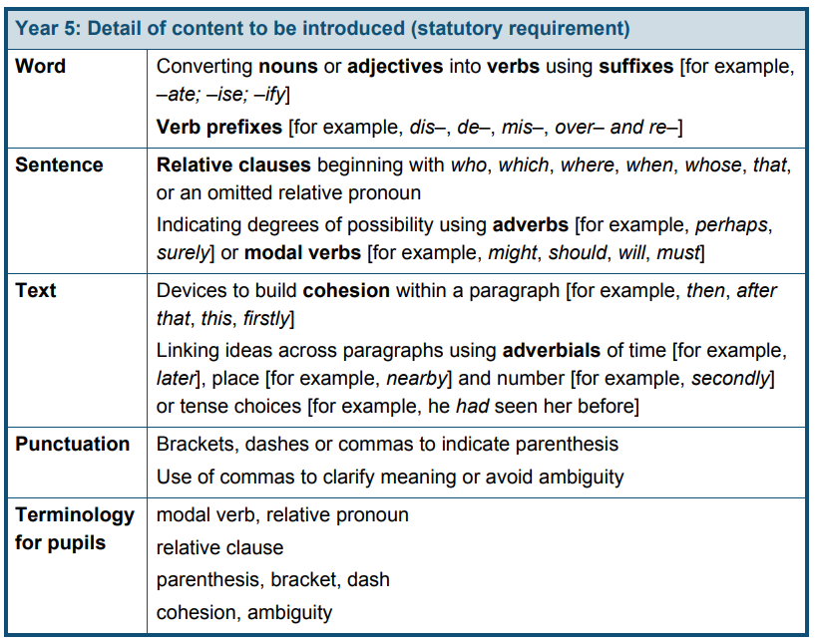
6 | Narrative Traditional Tales Hansel and Gretel | Narrative Romance: Paperman  Non-Fiction Recount Letters from the Lighthouse | Non-Fiction Persuasive Speech: Anglo-Saxon Battle  Book Week - Poetry |  | Non-Fiction Postcard: Fairy Tale Characters in Prison |  | Narrative Ghost Story Thornhill  Non-Fiction Newspaper Report | Narrative Mystery: The Graveyard Book
Personalisation/  Subject links |  | Letters from the Lighthouse links with our History topic on WW2. | The Anglo-Saxon Battle links with our history topic of the Vikings |  |  |  | Newspaper links to our ‘reading for pleasure’ book, Off Side.
Writing  Transcription | - use further prefixes and suffixes and understand the guidance for adding them  - spell some words with ‘silent’ letters [for example, knight, psalm, solemn]  - continue to distinguish between homophones and other words which are often confused  - use knowledge of morphology and etymology in spelling and understand that the spelling of some words needs to be learnt specifically, as listed in English appendix 1  - use dictionaries to check the spelling and meaning of words  - use the first 3 or 4 letters of a word to check spelling, meaning or both of these in a dictionary  - use a thesaurus
Writing  Composition | Plan their writing by:  - identifying the audience for and purpose of the writing, selecting the appropriate form and using other similar writing as models for their own  - noting and developing initial ideas, drawing on reading and research where necessary  - in writing narratives, considering how authors have developed characters and settings in what pupils have read, listened to or seen performed  Draft and write by:  - selecting appropriate grammar and vocabulary, understanding how such choices can change and enhance meaning  - in narratives, describing settings, characters and atmosphere and integrating dialogue to convey character and advance the action  - précising longer passages  - using a wide range of devices to build cohesion within and across paragraphs  - using further organisational and presentational devices to structure text and to guide the reader [for example, headings, bullet points, underlining]  Evaluate and edit by:  - assessing the effectiveness of their own and others’ writing  - proposing changes to vocabulary, grammar and punctuation to enhance effects and clarify meaning  - ensuring the consistent and correct use of tense throughout a piece of writing  - ensuring correct subject and verb agreement when using singular and plural, distinguishing between the language of speech and writing and choosing the appropriate register  Proofread for spelling and punctuation errors  Perform their own compositions, using appropriate intonation, volume, and movement so that meaning is clear
Vocabulary, Grammar and Punctuation | Develop their understanding of the concepts by:  - recognising vocabulary and structures that are appropriate for formal speech and writing, including subjunctive forms  - using passive verbs to affect the presentation of information in a sentence  - using the perfect form of verbs to mark relationships of time and cause  - using expanded noun phrases to convey complicated information concisely  - using modal verbs or adverbs to indicate degrees of possibility  - using relative clauses beginning with who, which, where, when, whose, that or with an implied (ie omitted) relative pronoun  - learning the grammar for years 5 and 6  Indicate grammatical and other features by:  - using commas to clarify meaning or avoid ambiguity in writing  - using hyphens to avoid ambiguity  - using brackets, dashes or commas to indicate parenthesis  - using semicolons, colons or dashes to mark boundaries between independent clauses  - using a colon to introduce a list  - punctuating bullet points consistently  Use and understand the grammatical terminology accurately and appropriately in discussing their writing and reading |  |  |  |  | 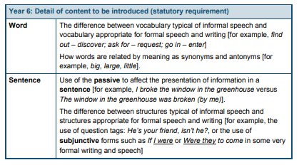  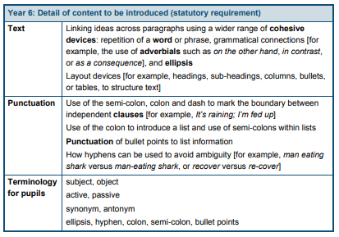

Narrative
Adventure
Story
Traditional Tale
Science Fiction
Mystery
Fantasy
Romance
Ghost Story

Non-Fiction
Recount
Post card
Biography
Persuasive speech
Newspaper Report
Speech
Journal
Diary
Instructions
Non-Chron Report
Explanation
Playscript

Poetry
Rap
Humerous
List
Acrostic

