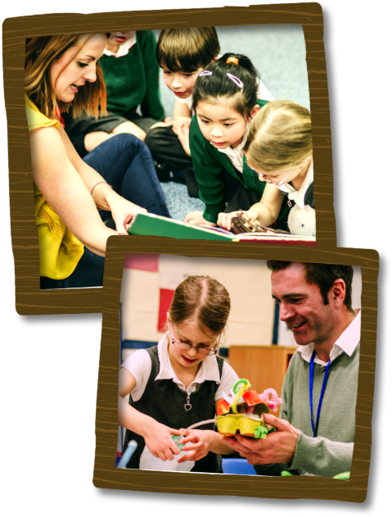

Manor Road Primary School

To realise our vision, we aim to…
- Ensure our school is a nurturing and happy family where everyone is valued for their individuality within a safe and secure environment. –Encouraging respect and understanding for all religious / non-religious beliefs and values.
- Equip children with the resilience and perseverance to become creative, independent thinkers. – Thinking about where we belong in the world.
- Encourage learning for life within an ever-changing world. – Make sense of a complex world with religious and cultural differences.
- Foster an enquiring mind in order to stimulate reflection, challenge and innovation both inside and outside the classroom. - Ask questions about the meaning of life. Reflect upon and make sense of their role within the world.
- Provide first hand experiences in order to develop in our children a love of learning, a pride in their work, respect for their surroundings and good relationships with others- Religious visits and visitors.
- Promote rights and attitudes of care, tolerance, trust and respect through a broad and balanced curriculum. – RE promotes moral, mental and spiritual development in pupils enabling them to value relationships and develop a sense of belonging.
- Build strong, collaborative partnerships between the school and wider community- Working alongside / visit our alliance schools to compare / share the teaching of RE. Visit local places of worship.

