Phonics Expectations
Daily Discrete Phonics session - from Phase 2 onwards
Model for daily teaching of phonic skills and knowledge
Multi-sensory, interactive and FUN
REVISIT AND REVIEW

Recently and previously learned phoneme-grapheme correspondences, blending and segmenting skills as appropriate

TEACH

New phoneme-grapheme correspondences; skills of blending and segmenting; tricky words

PRACTISE
New phoneme – grapheme correspondences; skills of blending and segmenting

APPLY

New knowledge and skills while reading/writing (writing every session from phase 2)
Year Group: Reception
Bug Club Phonics is followed throughout EYFS & KS1 using the Pearson Bug Club Phonics books and the Active Learning interactive reading platform online.

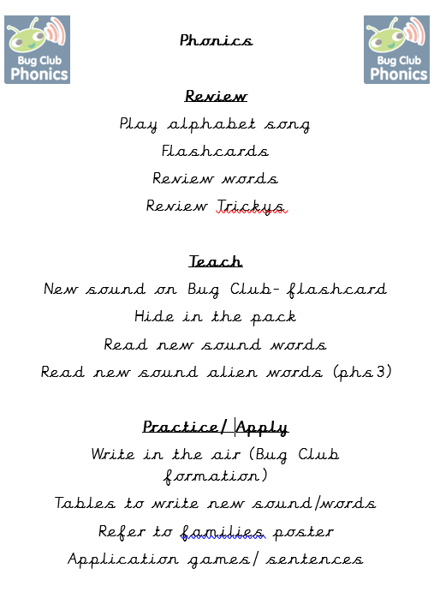

Phase 1 throughout | Reception  Autumn Term
 |  | Phase/ Set | Sounds | HFW | Tricky Words
 | Week 1  ASSESSMENTS  TO GROUP | Phase 1 | Aspect 1/2/3 General sound discrimination- environmental
 | Week 2  ASSESSMENTS  TO GROUP | Phase 1 | Aspect 4/5/6
 | Week 3 | Phase 1 | Aspect 7- Oral blending and segmenting
 | Week 4 | Phase 2 Set 1 | s a t p | a | Alphabet song daily- letter names BUG CLUB
 | Week 5 | Phase 2 Set 1 | i n m d | Is in it at
 | Week 6 | Phase 2 Set 2 | g o c k |  | and to  Start Reading books- fluency should be 90%
 | Week 7 | Phase 2 Set 4 | ck e u r |  | go the no
 | Week 8 | Phase 2 Set 5 | h b f/ff s/ss l/ll |  | I into
 | Week 9 |  | All Phase 2 reading and writing cvc words/trickys |  | I into  Phonic Probes for those children needing extra intervention
 | Week 10 | ASSESSMENTS  Identify gaps for planning. Ensure children are now writing and reading cvc words. Pass to DHT
 | Week 11 | Phase 3 Set 6 | J v w x |  | me be
 | Week 12 | Phase 3 set 7 | Y z qu |  | he my by

Phase 1 throughout | Reception  Spring Term
 |  | Phase/ Set | Sounds | HFW | Tricky Words
 | Week 1 | Phase 3 set 8 | Sh ch th ng |  | they she
 | Week 2 | Phase 3 vowel digraphs | ai ee igh ow |  | we are
 | Week 3 | Phase 3 vowel digraphs | Oo ar or |  | they she we are
 | Week 4 | Phase 3  Vowel digraphs | Ur ow ir |  | you her
 | Week 5 | Phase 3  Vowel digraphs | Ear air ure |  | all was
 | Week 6 | Phase 3 vowel digraph | Er  Revise all sounds |  | all was
 | Week 7 | Assessment | Revise all sounds |  | All are
 | Week 8 | ASSESSMENTS  Identify gaps for planning. Ensure children are now writing and reading cvc words. Pass to DHT and phonic probes information
 | Week 9 | Phase 4 cvcc words |  |  | said have like so do
 | Week 10 | Phase 4 cvcc ccvc ccvcc words |  |  | some come were there
 | Week 11 | Phase 4 tricky words adjacent consonants  Cccvc cccvcc |  |  | little one when out what
 | Week 12 | Phase 4 HFW and adjacent consonants

Phase 1 throughout | Reception  Summer Term
 |  | Phase/ Set | Sounds | HFW | Tricky Words
 | Week 1 | Recap on phase 2/3/4 | All sounds | All HFW | All tricky words
 | Week 2 | Sentence work using all sounds in phase 2 /3 and cvcc words | All sounds  Zh wh ph | All HFW | All tricky words
 | Week 3 | Phase 5  Families throoughout | Ay a-e ie ey ai family |  | Oh their people
 | Week 4 | Phase 5 | Ay a-e ie ey ai family |  | Mr Mrs
 | Week 5 | Phase 5 | Ea ee e-e ie ey y family |  | Called asked looked
 | Week 6 | Phase 5 | Ea ee e-e ie ey y family |  | Called asked looked
 | Week 7 | Phase 5 | Igh ie i-e y i family |  | Water where
 | Week 8 | Phase 5 | Igh ie i-e y i family |  | Water where
 | Week 9 | Phase 5 | Ow o-e o oe family |  | Who again
 | Week 10 | Phase 5 | Ow o-e o oe family |  | Who again
 | Week 11 | Recap  Assessments and groupings for Year 1 to DHT
 | Week 12 | Recap  Assessments to DHT

Year Group: Year One

Year One
Autumn Term
 |  | Phase/ Set | Sounds | CEW | CEW Spelling
 | Week 1- 6  Revision term and catch up- a big focus on writing sentences and applying the sounds taught in EYFS in Phase 3 and 4. | All phase 3 4 5 Ensure all children know ALL sounds to date ( ow family ) and complete boosters, probes, extra sessions, lower 20% focus, alien words. | ALL | Focus on completing the Y1 words and reading.  HA children move to Y2 words once secure and embedded in work. | Focus on completing the Y1 words and spelling.  Sentences a big focus this half term.
 | Week 7 | Assessment | Check and group | Complete Y1 assessment CEW | Complete Y1 assessment CEW
 | Week 8 | Phase2, 3, 4 ,5 Assessed Gaps  PLAN Catch up extra sessions
 | Week 9 | Phase 5 | Ay a-e ie ey ai family |  | Oh their people Mr Mrs
 | Week 10 | Phase 5 | Ea ee e-e ie ey y family |  | Looked called asked
 | Week 11 | Phase 5 | Igh ie i-e y i family |  | Water where
 | Week 12 | Phase 5 | Ow o-e o oe family |  | Who again
Phase 1 throughout | Year 1  Spring Term
 |  | Phase/ Set | Sounds | CEW Reading | CEW Spelling
 | Week 1 | Assessment | Check and group | Complete Y1 assessment CEW | Complete Y1 assessment CEW
 | Week 2 | Phase 5 | Aw au al or family |  | Work laughed because
 | Week 3 | Phase 5 | Ir er ur ear |  | Thursday Saturday thirteen thirty
 | Week 4 | Phase 5 | Ow ou  Oi oy |  | Different any many
 | Week 5 | Phase 5 | Ear ere eer  Air ear are |  | Eyes friends
 | Week 6 | Phase 5 | C k ck ch |  | Two once
 | Week 7 | Phase 5 | Ce ci cy  Sc stl se |  | Great clothes
 | Week 8 | Phase 5 | g(e)/g(i)/g(y), dge |  | It’s I’m I’ll I’ve
 | Week 9 | Phase 5 | le, mb, kn/gn, wr |  | Don’t can’t didn’t
 | Week 10 | Phase 5 | tch, sh, ea, zh, (w)a, o |  | First second third
 | Week 11 | Assessments and gap analysis on Bug Club  PSC assessment and gaps
 | Week 12 | All sounds to date |  |  | All trickys- spelling focus

Phase 1 throughout | Year One  Summer Term
 |  | Phase/ Set | Sounds | CEW | CEW Spelling
 | Week 1  Unit 28 Bug Club | suffix morphemes ing, ed |  | clearing, gleaming, rained, mailed
 | Week 2  Unit 29 Bug Club | plural morphemes s, es |  | men, mice, feet, teeth, sheep
 | Week 3  Unit 30 Bug Club | prefix morphemes re, un prefix+root+suffix |  | vowel, consonant, prefix, suffix, syllable
 | Week 4 | All of Phase 5 |  |  | Spelling focus and sentence work
 | Week 5 | All of Phase 5 |  |  | Spelling focus and sentence work
 | Week 6 | Assessments, PSC, next steps and gap analysis to inform next 6 weeks.
 | Week 7
 | Week 8
 | Week 9
 | Week 10
 | Week 11
 | Week 12 |  |  |  | Assess, re group and pass info to DHT

Year Two
Autumn Term Children split into 2 groups- whole class Jane Considine Spelling
Phonic group as below
 |  | Phase/ Set | Sounds | CEW | CEW Spelling
 | Week 1 | Phase 5 SPELLING FOCUS | Ay a-e ie ey ai family | Year 1 and 2 over the Autumn Term | Recap Year 1 CEW and assess Year 2 CEW
 | Week 2 | Phase 5 | Ea ee e-e ie ey y family
 |  | Phase 5 | Igh ie i-e y i family
 | Week 3 | Phase 5 | Ow o-e o oe family
 |  | Phase 5 | Oo ue ew u-e u family
 | Week 4 | Phase 5 | Aw au al or family
 | Week 5 | Phase 5 | Ir er ur ear family
 | Week 6 | Phase 5 alternative spellings | Ow ou  Oi oy
 | Week 7 | Phase 5 alternative spellings | Ear ere eer  Air ear are
 | Week 8 | Phase 5 alternative spellings | C k ck ch
 | Week 9 | Phase 5 | Ce ci cy  Sc stl se
 | Week 10 | Phase 5 | Ge gi gy dge
 | Week 11 |  | Le mb kn gn  Tch sh ea
 | Week 12 | REVIEW AND ASSESS Reading and spelling and pass info to DHT.

All of Year 2 accessing Jane Considine The Spelling Scheme

